IT University of Copenhagen **Date:** October 9th  
**Course:** Software Engineering **Supervisor:** Renata  
**Group:** 16 **Version:** 3  
**Document nr:** 9 **Tollgate:** 1  
**Responsible:** Peter **Status:** Ready for TG1

Portfolio document 9

Configuration Management Plan

**Students:** **Student ID:** **Email:**  
Carl Villads Dissing Fristam 17950 [cavf@itu.dk](mailto:cavf@itu.dk)Cecilie Malmberg 20963 [cecm@itu.dk](mailto:cecm@itu.dk)Luca Giannini 22150 [lgia@itu.dk](mailto:lgia@itu.dk)Peter Klarskov 19517 [pekd@itu.dk](mailto:pekd@itu.dk)Victoria Hinley Deng 17952 [vide@itu.dk](mailto:vide@itu.dk)

|  |  |  |  |
| --- | --- | --- | --- |
| Version | Change | Author | Date |
| 0 | Created general front page and CM plan including document convention | Peter | 24.09 |
| 1 | Made small adjustments to the cover page formatting | Peter | 28.09 |
| 2 | Added a page break to after the changelog instead of spacing | Luca | 28.09 |
| 3 | Added extra information on metadata, document layout and changelog for resubmission. | Peter | 09.10 |
|  |  |  |  |
|  |  |  |  |
|  |  |  |  |

# Configuration items

Our configuration management plan is mostly designed to structure and facilitate the creation and handling of documents. These documents belong to two different groups: One consists of the official portfolio documents which will be released and handed in for tollgates and our final submission. The other consists of documents of a more temporary nature, for example those pertaining to group discussions, meetings and exercises in class.

The first group of documents are handled via a rigid structure. Their first page has certain meta-data and important information that will be discussed in the following sections of the configuration management plan. They also have a changelog that tracks different versions and changes as they happen. Work on these documents is delegated strictly via Trello tasks handled by our scrum master.

The other group of documents are handled on a more individual basis. Their internal structures are allowed to be flexible to accommodate the needs of the individual task for which they were created. Other types of files, like mock-up images, are handled similarly. Nevertheless, these documents and files are backed up and saved both on the Teams server and in our GitHub repository. For this reason, they must be named in accordance with our simple naming convention to ensure that the overall structure remain intact, and the files can be found easily later if reinspection becomes necessary.

# Tools

We have decided to work in Microsoft Teams, which is a cloud-based business communication platform with built-in file storage and Microsoft Office integration. Using this tool allows us some major affordances in certain areas.

**Versioning a**nd data security

Microsoft Teams comes with a built-in version control system that saves previous iterations of documents that have been altered in the service. This means that, as long as we handle every document within the Teams ecosystem, we will automatically have access to previous versions of documents if needed. This poses one significant risk - since our data is stored centrally, server wipes or bad-faith actors could delete all our work. Even if this event is very unlikely, its implications could prove fatal to our project. To mitigate this, we have setup an additional GitHub repository to save our progress bi-weekly. This repository is handled by our configuration manager and virtual use manager, Peter, and is otherwise inaccessible.

## Tracking changes

While not necessary in terms of data security, each document we make incorporates a changelog to better understand and track the progress of specific documents as they change with time. The information stored in the changelog is as follows:

* **Version #** which changes with every iteration of the document.
* **Change** which carries a small description of the specific changes made, not unlike a commit message in Git.
* **Author** detailing the person who made the change.
* **Date** to keep track of when that change was made.

This in conjunction with our version control system should make it easy to track (and backtrack) any changes made to the files and documents of the project.

## Mitigation of the “Double Maintenance” problem

Since Teams is a cloud-service that incorporates changes and updates to documents live as they are being made, it is very unlikely that two group members would ever accidentally work on the same document. This means that, apart from the work structure we employ with Trello, in which people are assigned to different tasks, Teams provides a second safety net to ensure that a group member is not imposing on, impeding or simply just duplicating another group member’s work. For this reason, team members are advised to only work on documents while they are connected to the internet.

## Document review and change

As part of our process, we review and approve documents made by other group members. As a rule, we do not make changes to documents authored by other group members without their input. Instead, we use the built-in comment tool to make change recommendations and allow the responsible author of the document to consider the proposed changes. The author will notify the team of their decision.

# Naming convention and document layout

## Naming convention

Since our versioning is handled entirely by our chosen tools and changes are tracked via the changelog and in Trello, there is little reason to include version numbers and similar effects in document titles. For this reason, our naming convention simply states that documents are titled exactly as they are presented to us in the official course overview. Our file structure thus looks like this, with every document being the latest version by default.

Figure 1:
Document setup for our project

Figure 1 - File structure

## Document layout

All other metadata is handled inside the document, and group members are advised to update this information every time they work on a document. The metadata that we track in each individual document can be seen below.

General information that is the same for every document:

* **Course and University name**
* **Group identification** including our group number, name of our supervisor and the email and student ID of each group member.

Specific document metadata:

* **Document Title and ID** as specified by the portfolio description.
* **Tollgate #** to keep track of the deadline for finalisation of that document.
* **Status**, which will either be *draft*, *ready for TG1*, *ready for TG2*, or *final*.
* **Version** reflecting the number of changes in the changelog of that specific document.
* **Responsible***,* which reflects the individual that has been granted responsibility for the specific document via Trello. This does not necessarily infer that the responsible person is the only author. All authors that have been working on a document should be identifiable in the changelog of the document.
* **Date** of when the last changes or updates were made.

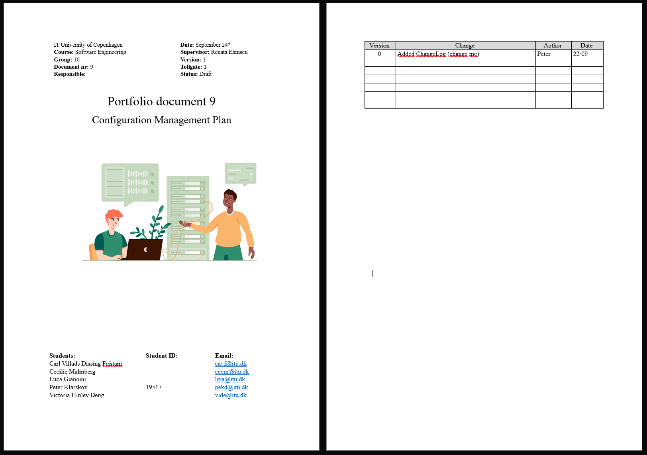

Figure 2 - Cover page example

# Document styling

To ensure consistency across our documents we have made the following decisions in terms of document styling:

**Font:** Times New Roman with a line spacing of 1.5.

**Titles:** Size 24, centred. Titles are only used on cover pages.

**Heading 1**: Size 14. Heading 1 is used to mark the beginning of a new section.

**Heading 2:** Size 12, bold. Heading 2 is used to mark the beginning of a new subsection within the current section.

**Body:** Size 12.

**Captions:** Size 9, italicised. Used to caption images and figures.